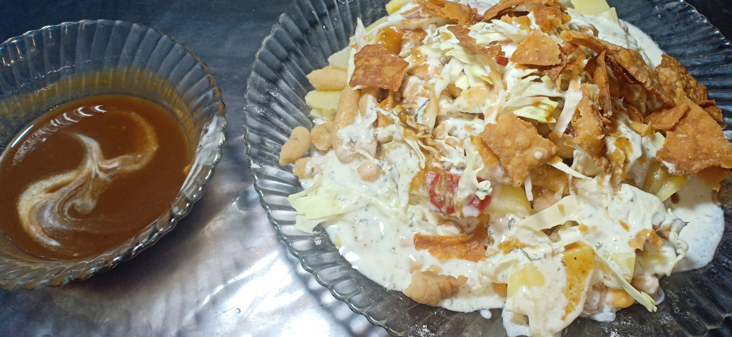

**Ingredients**

Serving 7- 10

* Potatoes boiled 1 kg
* Chickpea boiled 1 kg
* Dahi bhala soaked in water for 2 hours

**For papri**

* 1/3 kg All purpose flour
* ½ tablespoon salt
* 1 tablspoon oil
* Half cup luke warm water

**For Imli ki Chatni**

* 1/3 kg imli
* ½ tablespoon red chilli powder
* ½ tablespoon salt
* 1 tablespoon suger

**For mint chatni**

* 1 kg Yogurt
* 1 tablespoon mint grided
* 1 tablespoon salt

**For Assembling**

* 1 medium chopped onion
* 1 medium chopped tomato
* 1 medium chopped cabbage
* Chat masala

**Recipe**

**For papri**

* Add salt , oil , water in all purpose flour and knight the dough .
* Now make roti out of that dough and cut it into pieces then fry it until crispy brown

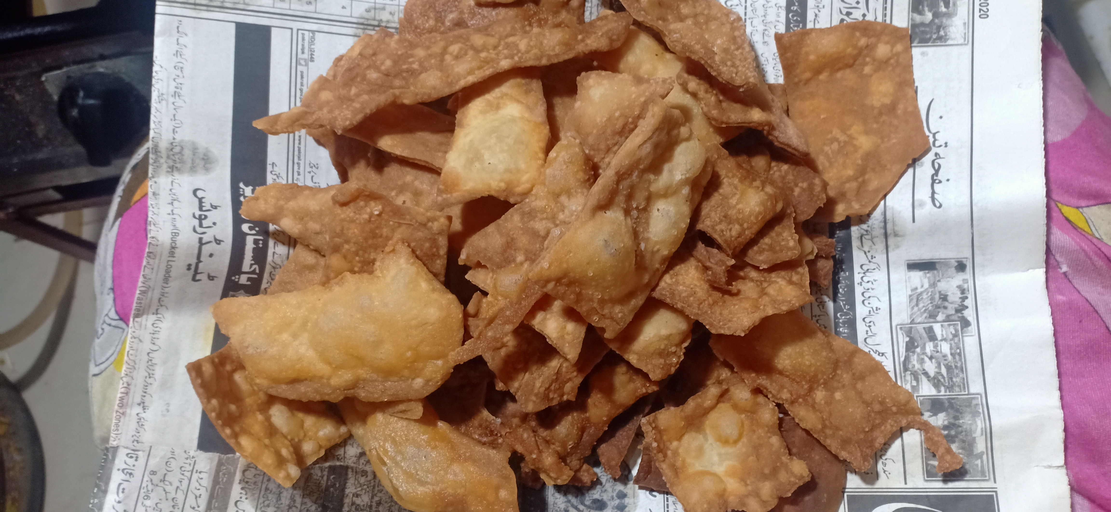

**For Imli ki Chatni**

* Soak imli in water for 1 hour then take that imli water in a pan .
* Place it on medium flame utill it bubbles then add suger , red chilli , salt .
* Turn the flame off after 5 min and let it cool.

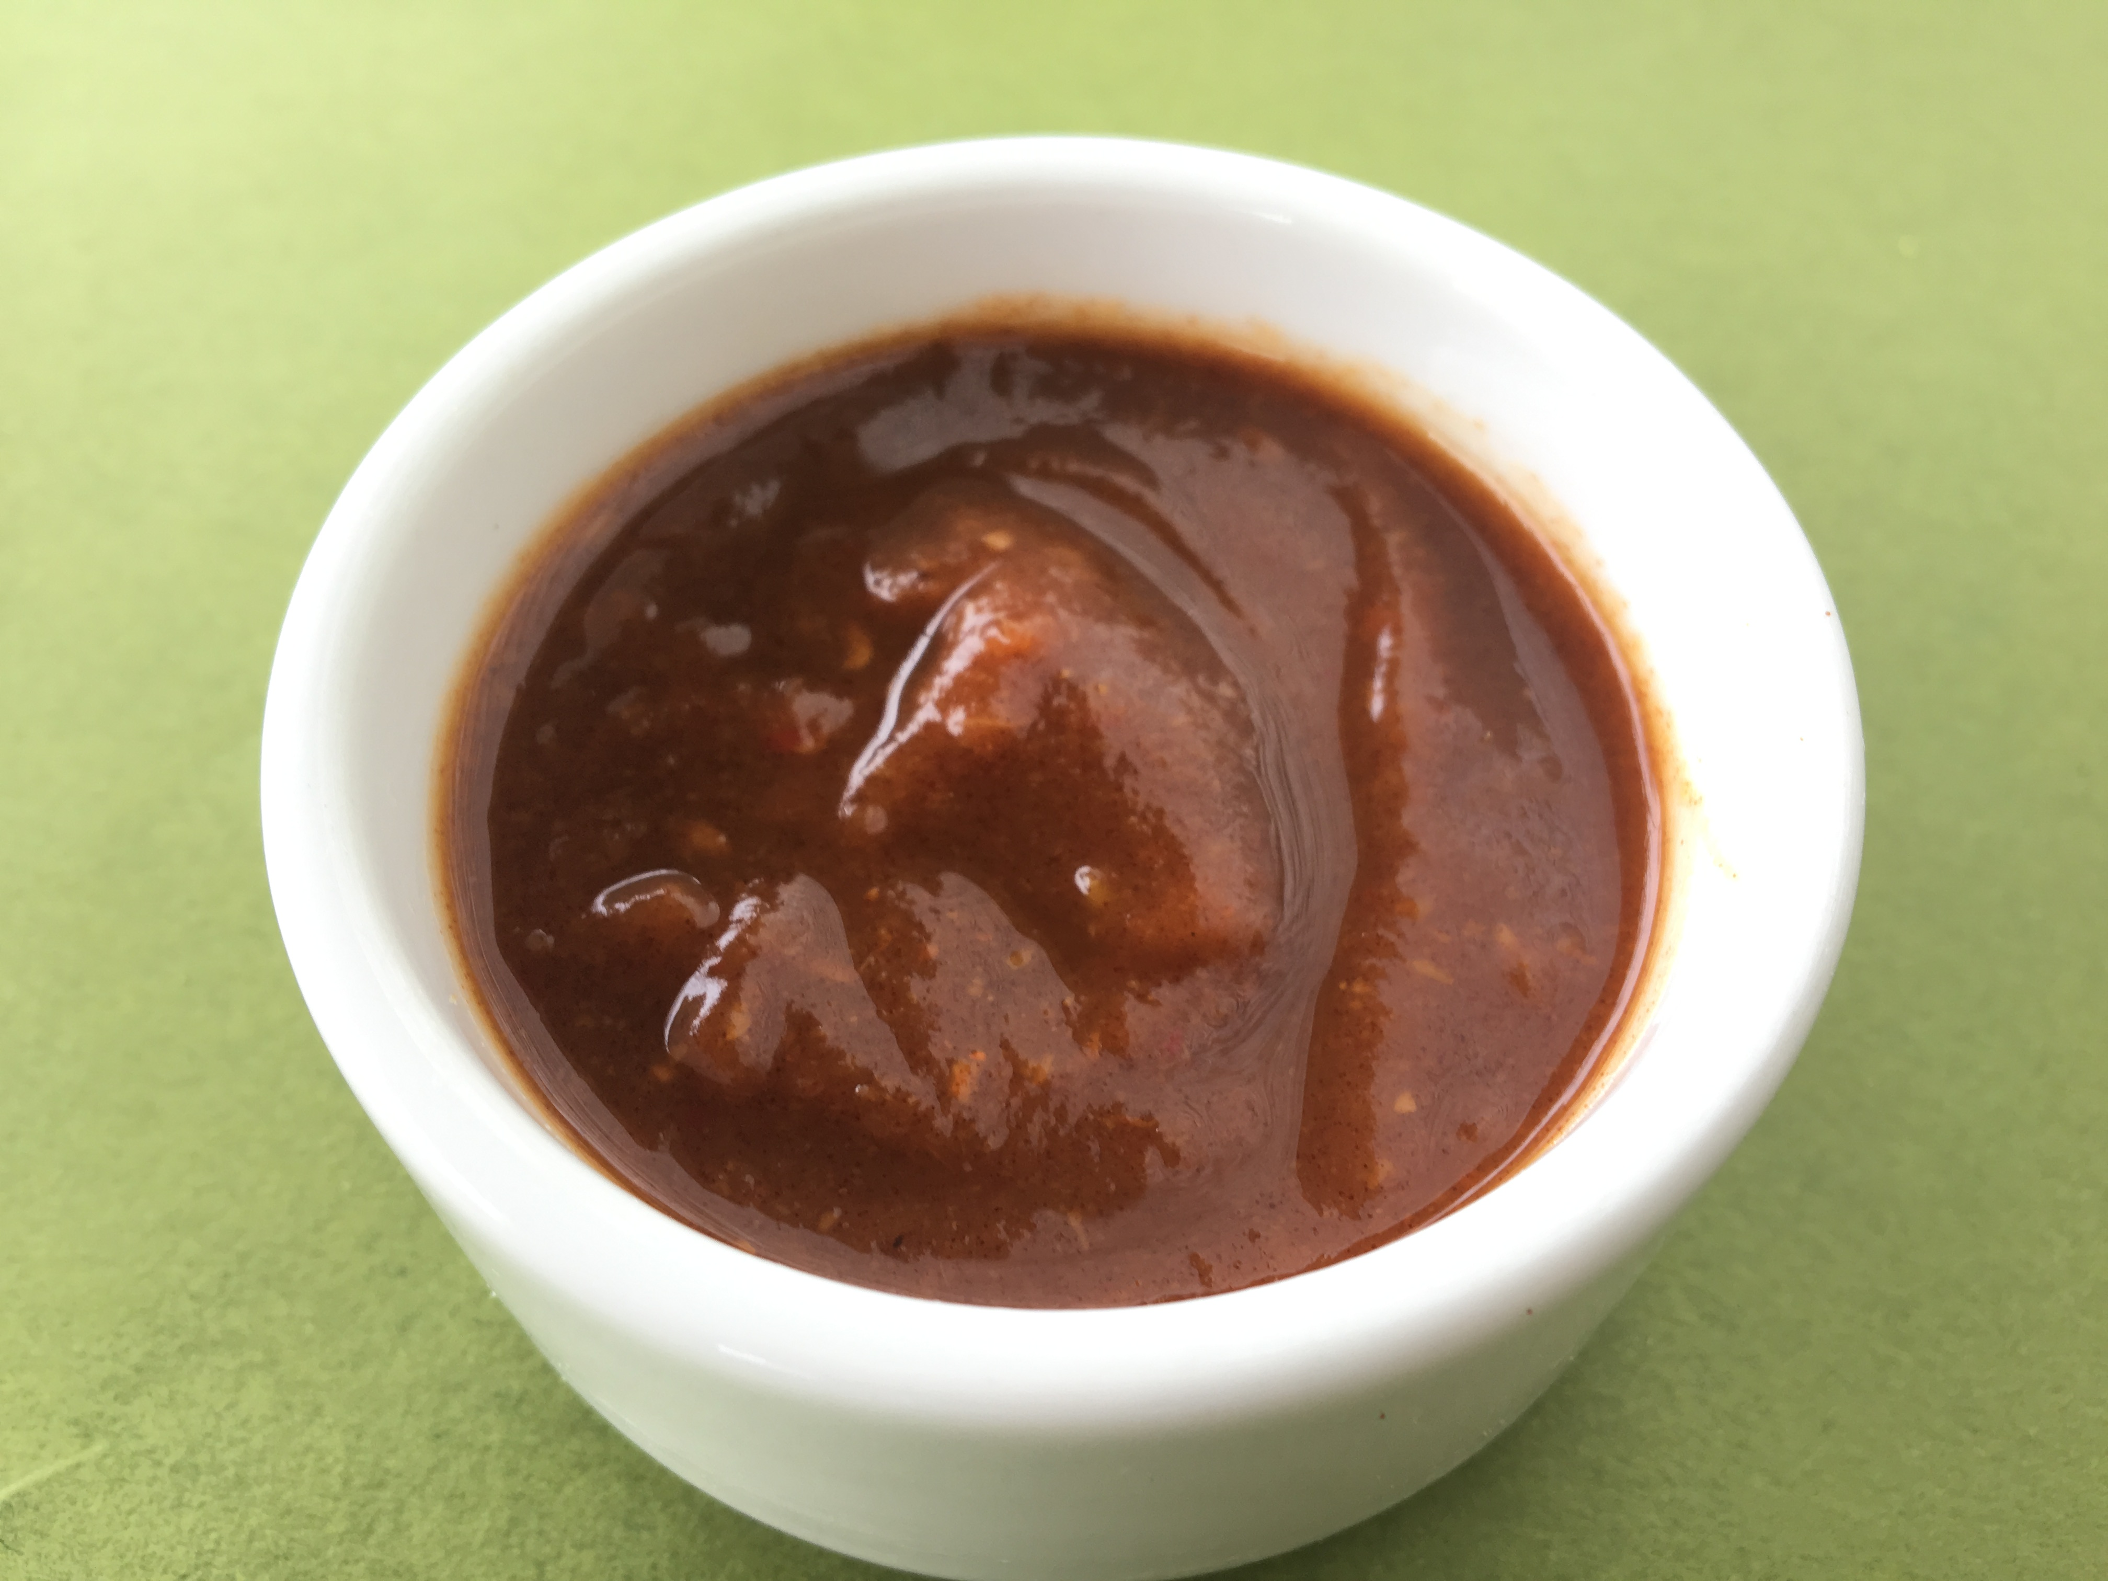

**For mint chatni**

* Add mint , salt in yogurt and mix it well.

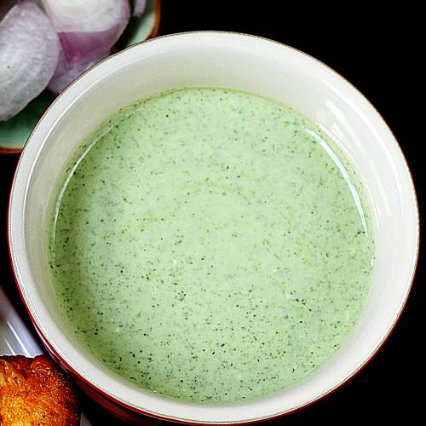

**For Assembling**

* Add potatoes , chickpea , bhala , tomatoes , onion , cabbage , mint chatni , imli chatni , papri , chaat masala and serve it .